Rep. Laura Sibilia’s 2026 Town Meeting Update
Dover | Jamaica | Somerset | Stratton | Wardsboro
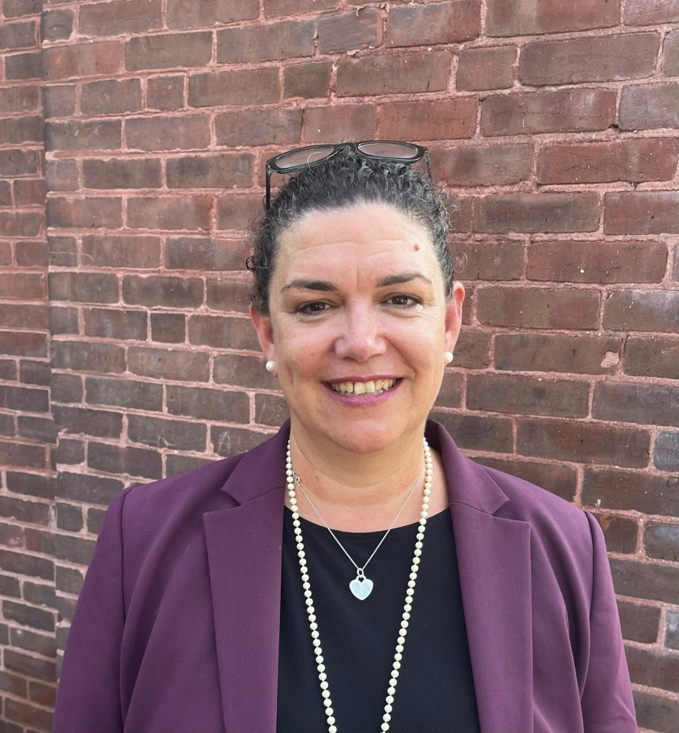
I am serving as the Ranking Member of the House Energy & Digital Infrastructure Committee and co-chair of the Legislative Rural Caucus, while also participating in national state legislative task forces focused on energy, cybersecurity, and emerging technologies.
During the first eight weeks of the 2026 session, my focus has been Act 250 reforms and major infrastructure proposals.
Through the Rural Caucus, I introduced legislation to adjust Act 181 implementation timelines with regional mapping so rural landowners are not subject to new Act 250 rules before being notified and having maps in place. In the House Energy and Digital Infrastructure Committee, on behalf of constituents in Dover and Wardsboro, I advocated for consumer protections during the transition from copper to fiber telecommunications to ensure Vermonters receive proper notice and maintain reliable 911 access. I’ve also introduced legislation to establish a proactive framework for potential large-scale data centers, so Vermont sets standards for water, energy and noise before proposals arrive.
I host monthly office hours at the Dover Free Library at noon on the first Saturday of the month year-round, on the 3rd Thursday evening of the month at 6 pm at the Wardsboro Library from June - December and also by appointment. You can track legislation at legislature.vermont.gov or reach me at (802) 384-0233 or lsibilia@leg.state.vt.us. Sign up for my weekly updates on state policy and the legislative session at www.LauraSibiliaVT.com
EDUCATION & PROPERTY TAXES
In his State of the State address, Governor Scott stated he will not sign a budget, education bill, or tax bill that deviates from Act 73 or fails to address structural cost issues, significantly raising the stakes.
Preliminary data show reporting districts averaging a 4.3 percent spending increase in proposed budgets, compared to the 5.8 percent projected in the December 1 tax letter. Enrollment continues to decline statewide, and previous gubernatorial and legislative decisions to buy down rates and shift new costs to the education fund are also adding pressure to property taxes. A proposal to cap the growth in spending does not yet have support to move to a vote in the Senate.
Act 73 governance reform discussions continue with competing redistricting maps introduced in both chambers. The House proposal aligns districts largely by county and geography. A Senate proposal aligns more closely by historic tuition patterns. These differences reflect one tension point in the broader reform debate: whether regional lines should prioritize geographic cohesion or relationships with private institutions.
H.750 proposes excluding voter-approved construction costs from excess spending penalties and clarifies how districts may proceed during the construction aid moratorium. I’ve also sponsored legislation to ensure that any school or district receiving public education dollars is held to the same accountability, transparency, and education standards.
STATE BUDGETS
The Governor’s FY27 budget proposal relies on one-time funds to buy down education property taxes for a single year while statewide education spending approaches $3 billion. When those one-time funds expire, property taxes will remain as the largest backstop for Education Fund shortfalls.
The Legislature unanimously passed the Budget Adjustment Act to address mid-year pressures, including nursing home stabilization, Medicaid caseload growth, corrections health care costs, mental health services, housing vouchers, and public safety overtime. Nearly $75 million was set aside to help manage potential federal funding instability heading into FY27.
Transportation funding remains structurally challenged. As vehicles become more fuel efficient and electric vehicle adoption increases, gas tax revenue continues to decline. Without structural reform, Transportation Fund shortfalls will persist. The Governor has stated opposition to raising the gas tax and has offered support for proposals to move some transportation related sales tax out of the education fund – which would put pressure on property taxes.
LAND USE: ACT 181 & ACT 250 IMPLEMENTATION
Act 181 represents the most significant expansion of Act 250 jurisdiction in decades, extending location-based land use regulation across much of Vermont. Implementation is underway, but concerns about timing have been expressed by many legislators, the Vermont League of Cities and Towns, The Vermont Chamber, Vermont Natural Resources Council, Let’s Build Homes and even the Land Use Review Board.

Tier 3 mapping, the Road Rule trigger, and regional plan updates are on different timelines. In some cases, new jurisdictional triggers could take effect before final maps are complete. Through the Rural Caucus, H.730 was introduced to improve mailed notice requirements, align property valuation changes with development limits beginning in the 2027 Grand List, allow housing to proceed in existing growth areas during transition, and better sequence implementation timelines. These proposals and others are expected to be a part of Senate Bill S.355

There is also debate about shifting Act 250 appeals from the Environmental Court to Land Use Review Board. Combining rulemaking and appeals authority within the same entities raises fairness and due process concerns for me, particularly while major jurisdictional changes are still being defined.

Act 181 is regularly described as a housing bill because of its Act 250 exemptions in population centers that have infrastructure and municipal regulatory staff, but it is also a significant conservation-driven expansion of land use regulation in rural Vermont.

PUBLIC SAFETY & ELECTION PROTECTIONS
The Senate has passed proposals related to transparency in law enforcement and access to essential public spaces, and the House is now reviewing them.
One bill would require law enforcement officers to clearly display identifying information, including name or badge number and agency, during public interactions. It limits the use of face coverings when they obscure identity, while explicitly allowing masks for legitimate health, safety, or hazardous duty reasons. The intent is to strengthen accountability and public trust while preserving officer safety.
A related proposal would restrict civil arrests, including immigration-related arrests, in designated “sensitive locations” such as schools, courthouses, health care facilities, emergency shelters, and places of worship. Supporters argue that individuals should be able to access essential services, education, and the courts without fear of disruption or intimidation. The bills do not change Vermont’s role in federal enforcement but clarify expectations around transparency and due process within the state.
The House also advanced H.541 to strengthen protections for voters and election officials by clarifying penalties for intimidation or interference with voting or election administration.
Separately, a voluntary regional public safety pilot has been proposed in Windham County. Towns could opt in to a shared governance model for policing, with local representation and oversight. If implemented, the pilot would be evaluated based on service quality, coordination, and cost effectiveness.
PILOT Fund Raid and Local Option Taxes
The state’s most recent end-of-year report shows a surplus of more than $15 million in the PILOT Special Fund. This fund is made up of local revenues, raised through voter-approved Local Option Taxes, and is intended to support payments back to municipalities for state-owned land and buildings.
In the Governor’s FY27 budget and recent House action, half of the PILOT surplus is proposed to be used for statewide property appraisal and equalization costs. I share the position of the Vermont League of Cities and Towns (VLCT) that these locally generated revenues should be returned to the municipalities that raised them.
